**PARADE USER GUIDE**

**User Interface**



**Version 1.59 Jul 2021**

**Version History**

|  |  |  |  |
| --- | --- | --- | --- |
| **Version** | **Date** | **Author** | **Comments** |
| 1.28 | Aug 2020 | K Wilson | Initial version |
| 1.30 | Sep 2020 | K Wilson | Added new menu options |
| 1.59 | Jul 2021 | K.Wilson | Update with new menu options, Help pages |

Contents

User interface 1

The Main screen 2

The Menu System 4

Main menu 4

The File menu 4

Scenario 4

Graphics 4

Tool box 5

Calculated data 5

Libraries 5

Window 5

Log Data 5

WITSML 6

Help 6

Table edit forms 7

Modal forms 9

Dual List Box 10

Plots 11

Depth plots 11

Path Plots 12

Reports 13

Help Pages 14

# User interface

Parade is a Windows program that displays information from data tables, allows entry of values, performs calculations and creates reports and plots.

The program is controlled by a set of menus, which determine which forma are displayed. In addition to the many forms that display data, there are forms to perform various processes.

When the program starts a Splash screen is displayed and files are loaded in to memory.



This screen displays the version number and development date and at the bottom a status message indicates what processes are being performed.

# The Main screen

Once the files are loaded, the main form appears.

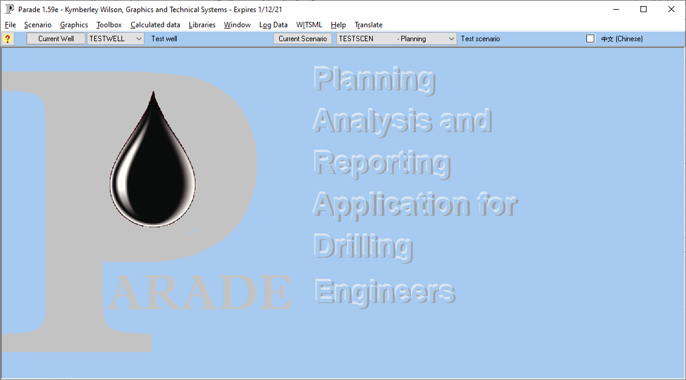

The form title displays the version number the user name and company and the expiry date.

Under this is the Main menu, which is displayed horizontally across the top of the main screen. The options in the main menu have their own dropdown menus, which appear when you clicked on them.

The next line shows the current well and scenario being process. These are selected from drop down combo boxes.

The [Current Well] and [Current scenario] buttons will display the Wells table and Scenario tables, respectively.

The rest of the screen is an MDI (Multiple Document Interface) display area, where the various forma is displayed when selected.

If a second language is available, a check box will be visible to turn on the second language.

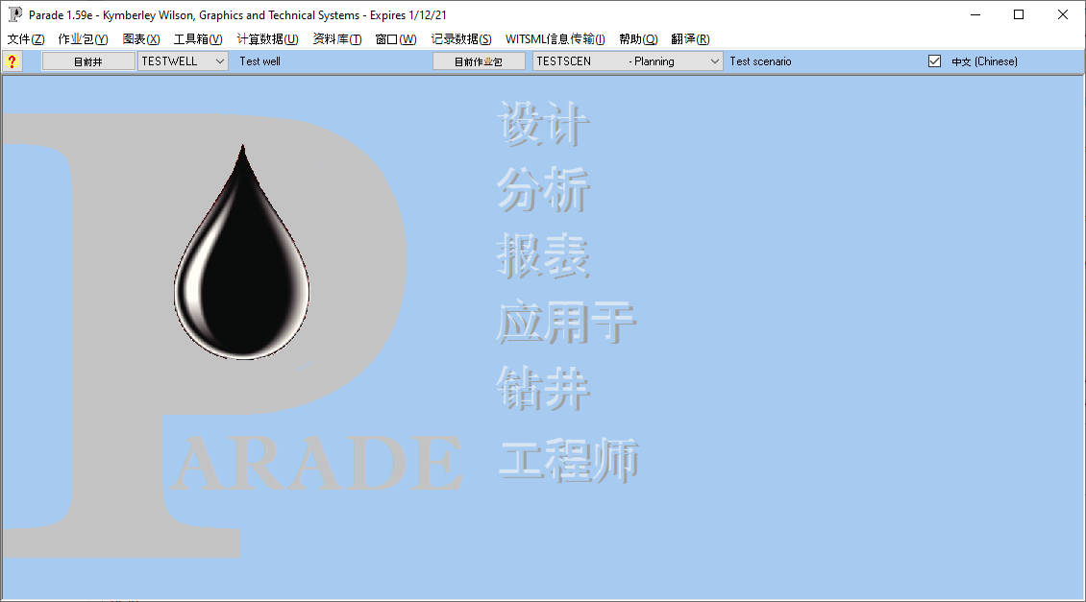

# The Menu System

## Main menu

The option in the main menu are:

* **File** - Define wells and scenarios, select units and enter registration data.
* **Scenario** – Define the scenario parameters and input data. Import and display Measured Data and Rock Mechanics
* **Graphics** – Define and display plots
* **Toolbox** – Bit and surface hydraulics
* **Calculated data** – Display calculated Torque and Drag and Hydraulics data.
* **Libraries** – Display libraries and templates, accessible to all wells
* **Window** – Display, select and arrange forms
* **WITSML** – Import data from WITSML files
* **Help** – Access help and other information

## The File menu

* **Wells** – View wells, create new ones or register a well directory and its data.
* **Scenarios for well** – List the scenarios for the current well, create new ones
* **Units** – select the units for each of the unit types, with defaults for API and Metric
* **Registration** – Enter user information and registration and expiry codes
* **Backup Scenario** – Back up Scenario and system files
* **Restore Tables** – Selectively copy files from the backup directories to the system or scenario

## Scenario

* **Calculations** – Enter scenario parameters and risk factors, select calculations and run them, view plots of calculated data.
* **Well Path** – enter or import well path data, run calculations on it and generate and display plots.
* **String and accessories** – define the drill string or casing. This can be built from components defined in the library.
* **Hole profile** – define the hole profile. Items can be copied from the library
* **T&D measured data** – Import and view Torque and Drag related data measurements from the actual well section
* **Hyd measured data** – Import and view Hydraulics related data measurements from the actual well section
* **S&S measured data** – Import and view Surge and Swab related data measurements from the actual well section
* **Rock Mechanics** – Import and view Fracture and Collapse Gradient and Pore pressure data

## Graphics

* **Plot Selection** – Select the calculation type and then the plot type for plotting.
* **Depth plots** – View and edit the plot definitions and display depth plots
* **Path plots** – View and edit the plot definitions and display path plots

## Tool box

* **Bit Hydraulics** – enter or calculate effective flow area from nozzles and then calculate bit performance values for different flow rates.
* **Surface Hydraulics** – Calculate pressure losses in surface equipment at different flow rates.

## Calculated data

* **TAD Surface data** – View data from Torque and drag calculations as seen by surface gauges (Driller’s view) at different bit depths
* **TAD Profile data** – View data from Torque and drag calculations at different depths along the hole for a fixed bit depth
* **Hydraulics Surface data** – View data from Hydraulics calculations as seen by surface gauges (Driller’s view) at different bit depths
* **Hydraulics Profile data** – View data from Hydraulics calculations at different depths along the hole for a fixed bit depth
* **Surge and Swab Surface data** – View data from Surge and Swab calculations as seen by surface gauges (Driller’s view) at different bit depths
* **Surge and Swab Profile data** – View data from Surge and Swab calculations at different depths along the hole for a fixed bit depth

## Libraries

* **String components** - a library of different types of items that can be used to create a scenario string.
* **Pipe grade minimum yield** – Physical parameters of different pipe grades and materials
* **Materials** – Physical properties of different materials used in strings
* **Hole sizes –** Hole diameters and Casing IDs
* **Import formats –** templates for importing different sets of data from text files supplied from 3rd parties
* **WITSML export formats –** templates for selecting curves from WITSML data to export to text files.

## Window

* **Tile –** arrange open forms as tiles
* **Cascade –** arrange open forms by cascading from the top left
* **Close all –** close all open forms (can be initiated by double click the Window menu item)
* All open windows are then listed and can be selected**.**

## Log Data

* **Log tables** – Define log tables, their fields and import data, display and manipulate data. Plots can be created and new curves calculated.
* **Log plots** - create and view plots of log data
* **Log import formats** – define the layout of text files containing log data
* **Log field templates** – Define the fields in log tables, for reuse when a similar table is created.
* **Log Calculation templates** – Define a sequence of calculation steps to calculate a new log curve.

## WITSML

* Import and view data a text file in WITSML format and export selected curves to a tab delimited file

## Help

* **Help files** – Display the pop up help page definitions and translations
* **Function keys** – display a popup listing short cut keys
* **About** – Display information about the program and license

# Table edit forms

Data tables are displayed using Table edit forms.

These consist of a grid which shows the data in a spreadsheet format and a pop up edit panel.

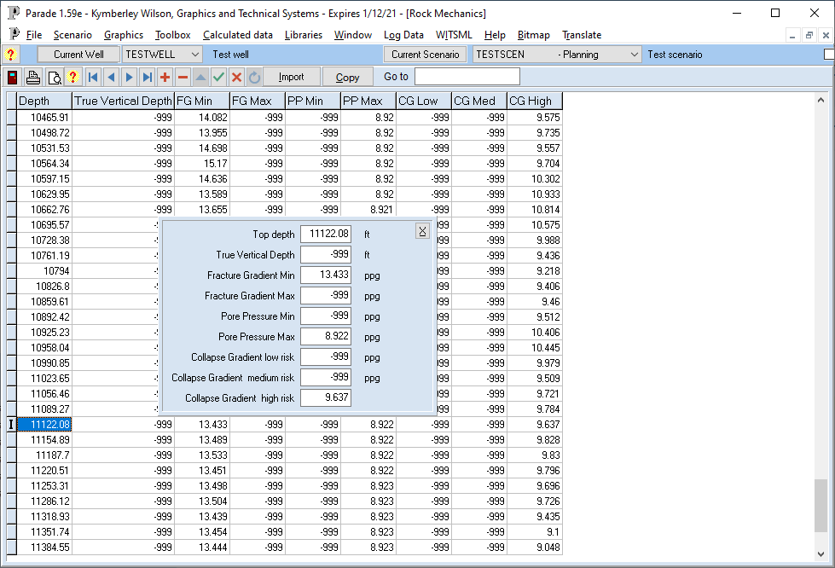

The grid view displays the whole of the table but, it may require you to scroll horizontally in order to see all the columns.

Each row is a single record with a key field, such as depth, a code, or a sequence number used to determine the order.

Each column is the value for a particular field in the table with a short title.

The edit panel will show all the fields for the record currently selected in the grid. It allows longer descriptions and the units to be displayed.

Both the edit panel and grid are “live, so changing a value in the grid will update the value in the panel and vice versa, once the cursor moves from the edit box or cell being edited

The grid is controlled by the Navigator which is a group of buttons at the top of the form.



The buttons have the following effect.

In most cases, there is a short cut key that can be used instead.

Some of the keys may be greyed out, depending on the state of the table.

 CRTL/PGUP Move to first record in table

 Up arrow Move to previous record

 Down arrow Move to next record

 CTRL/PGDN Move to last record

 F10 ` Add a new record

 F6 Delete the current record (Note: F6 does this without a warning)

 F2 Edit the current record

 F12 Save the current changes

 ESC Cancel the current changes

 F11 Refresh the table

In addition, the following buttons are also present on all table edit forms

 ESC Close the form (If editing or adding, the first esc cancels the edit)

 F7 Print a report with a listing of the table

 F8 Display a report on screen, with a listing of the data

 F1 Display help information for the screen

There is also, usually, a Got to option (F5). When text is entered in the edit box a search will be made for the record with the key field matching that text. This will depend on the index (sort order) that is active for the table.



Finally there will be additional buttons that vary from screen to screen.



These perform different actions, such as importing data, copying data from another scenario, running calculations, creating or displaying plots and so forth.

# Modal forms

Modal forms are pop up forms that must be closed before the underlying form can be accessed again.

These are used to enter parameters, define copy sources, import from files, select colours and so forth.

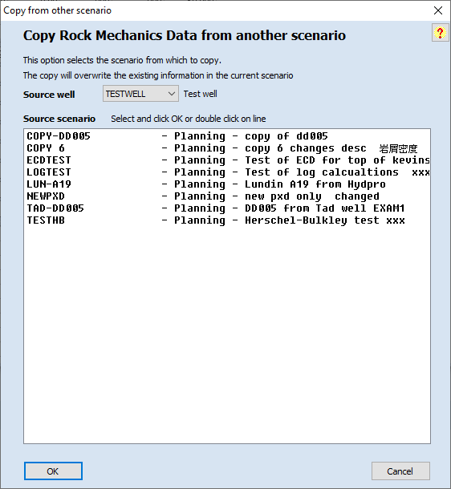

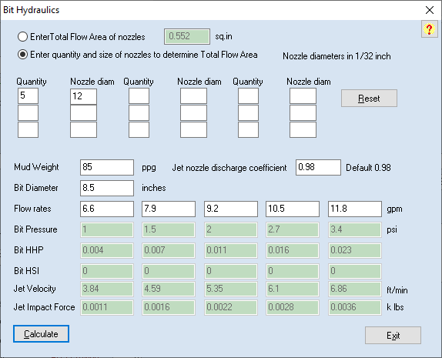

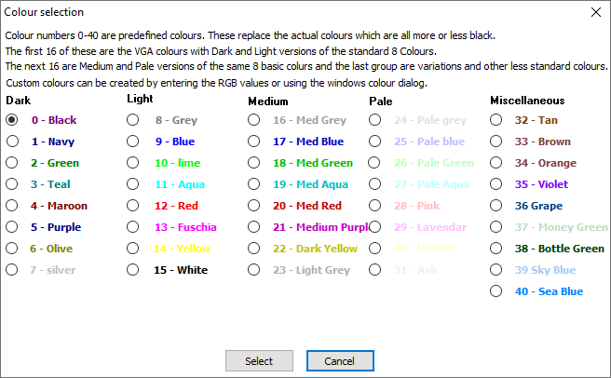

## Dual List Box

This is a special type of Modal form used to select a number of items from a list.

It has 2 list boxes. The left box displays available choices and the right show selected choices.

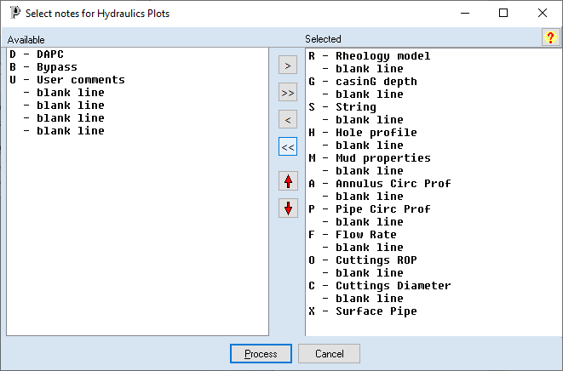

Items are moved from one list to the other by double clicking on them or by highlight one or more items in one list and using the buttons to move them.

[>] and [< ] Move the Highlighted items to or from the right hand list

[>>] and [<<] move all the items to or from the right hand list

Up and Down arrows move the highlighted items up or down one position in the list.

Use SHIFT and CTRL keys to select multiple items

# Plots

## Depth plots

The depth plot screen not only displays the plot but has a number of options to manipulate and export it.

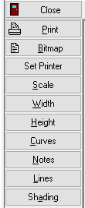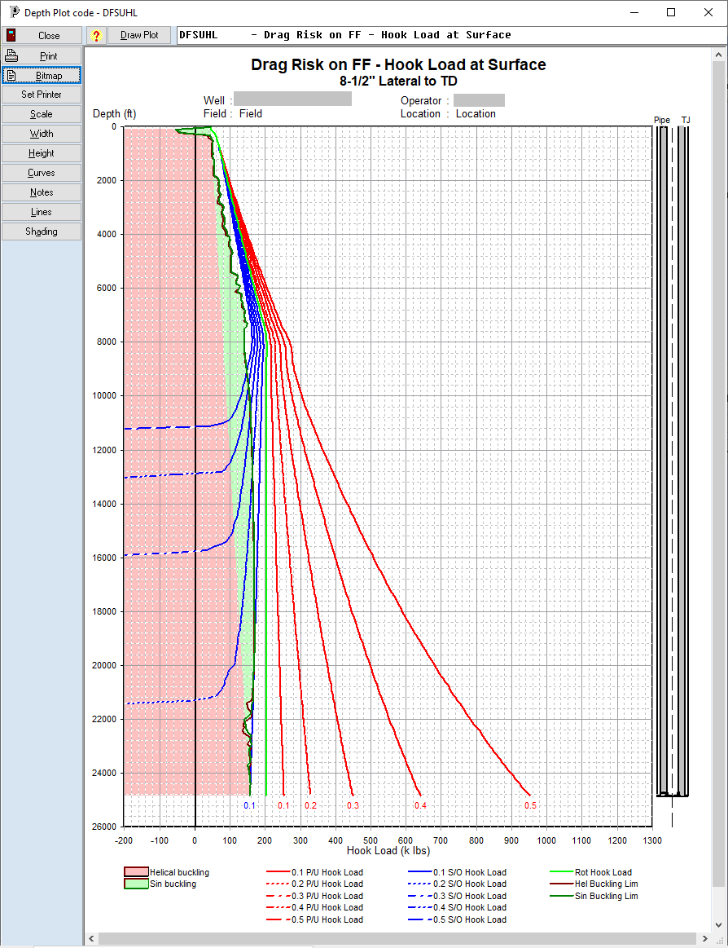

The current plot is selected in the Dropdown combo box above the drawing area. This can be used to select another plot. The [Draw Plot] button is used to redraw the current or newly selected plot.

The side buttons have the following functionality.

Close Closes the plot window

Print Prints the plot on the current printer

Bitmap Creates a bitmap file or saves the plot to the clipboard to paste into another application, eg a Word document. The file formats available are Bitmap (BMP), Jpeg (JPG) and Portable Network Graphics (PNG)

Set Printer Allows a different printer to be selected for printing

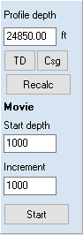Scale Displays a pop up form that allows the orientation and scaling to be changed

Width Redraws the plot so it fits the width of the drawing area

Height Redraws to fit the drawing area height

Curves Displays the curves edit form for the plot

Notes Displays the notes edit form for the plot

Shading Displays the shading edit form

In addition, for a plot of profile data, there is a panel which allows the depth of the bit to be changed. After a recalculation the plot will be drawn with the new profile

The Movie option results in multiple profile recalculations and redraws based on the starting depth and the increment.

## Path Plots

The plot form for path plots is similar but has fewer side button options

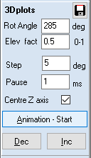Basically there are no buttons for Notes or Shading and there is no need to have a depth recalc option.

However there is a parameter change and animation option for 3D curves.

The rotation angle and elevation factors can be changed and the plot can then beredrawn from a different perspective.

It is also possible to do an animation of the curve rotating about the vertical access.

The change in angle between each plot and a pause length between redraws are specified.

The new plots can be manually steeped through or automated.

It is usually advisable to centre the Z axis to prevent the plot wander from one side of the drawing area to the other.

# Reports

Each table form has buttons to create a report which lists the records in the table.

If the view option is selected, the report screen is displayed

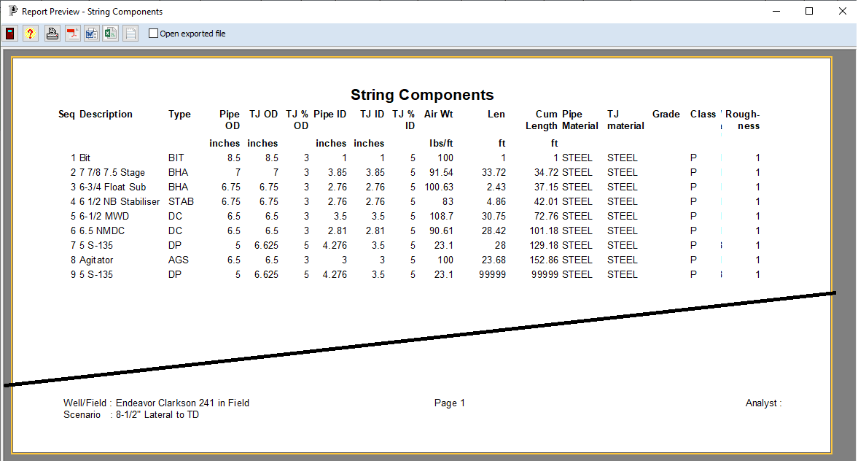

The report may be defined with either Portrait or Landscape mode (Fixed)

There are options at the top to print the report or export it to one of a number of file formats.

If the open exported file option is checked then the file created is then opened in the respective application.

The file formats and the usual applications are:

 PDF Acrobat Reader or equivalent

 RTF Microsoft Word

 CSV Microsoft Excel

 TXT Notepad

# Help Pages

The Help button will display the help page for the screen being displayed. It is at the top left of the table screens and the top right of the dialogs.

This form will sit in front of the other screens but can be moved and resized as required.

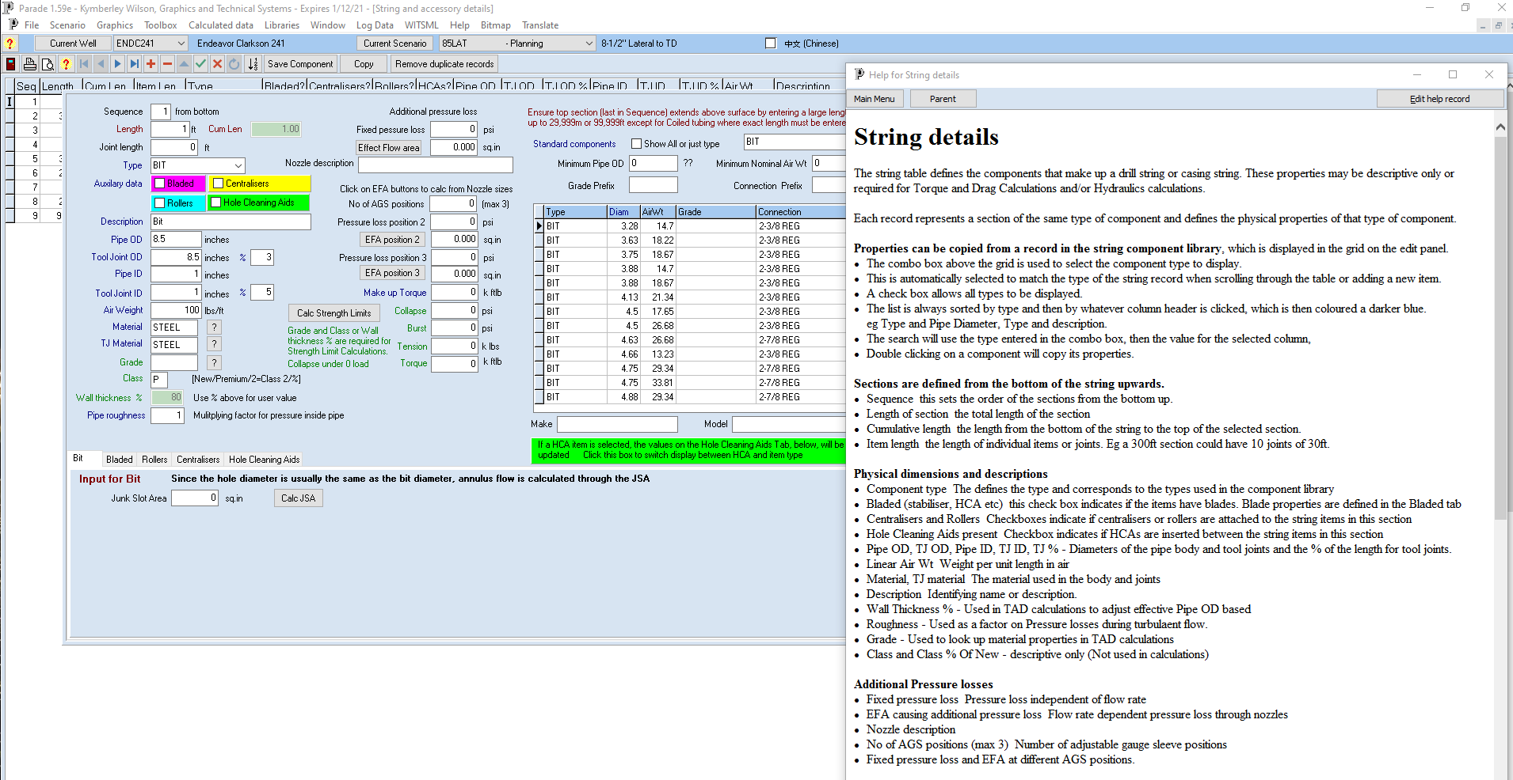

There are buttons to display the parent or Main menu help page.

If a second language is set up, help can be displayed in both languages

